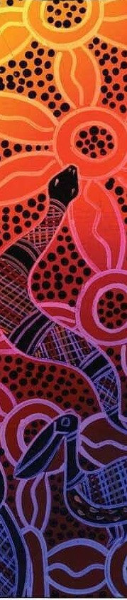
Cherbourg State SCHool
we are strong, we are smart, we are safe
Ngaringa Taring, Ngaringa Biyangga Mau, Ngaringa Ta-our Ngan’ya
Cherbourg State School acknowledges the Traditional Custodians of the land, the Wakka Wakka people,
of the country on which the school is located and pays respect to their Elders past, present and emerging.

Tuckshop Menu - Term 3 2022
EVERYDAY - | Large Pie | $4.00
 | Sausage Roll | $2.50
 | Mini Pie | $1.50
MONDAY - | Hot Dog | $3.00
 | Boiled Egg | $0.50
TUESDAY - Toasted | Chicken, Cheese & Mayo Sandwich | $3.50
 | Ham & Cheese Sandwich | $3.00
 | Ham, Cheese & Tomato Sandwich | $3.00
WEDNESDAY - | Mini Pizza | $3.00
 | Garlic Bread | $0.50
THURSDAY - | Chilli Chicken Wrap | $4.00
FRIDAY - | Toasted Ham & Cheese Wrap | $3.00

DRINKS
100% Juice Bottle | $2.50
Juice Poppers | $1.50
Flavoured Milk Popper | $2.50
Water Small | $1.00
Water Large | $1.50
ICE CREAMS
Paddle Pop | $2.00
Lemonade Ice Twist | $1.50
Vanilla Tub | $1.50
Calippo | $1.00
Long Ice block | $0.50
Chocolate Yoghurt Tub | $1.50

